SAMPLE ANSTRACT AND PREPARATION INSTRUCTIONS

T. Emplate¹ and I. N. Structions²

¹University of Carbon Nanotubes, Dourdan, 91200, FRANCE
²Graphene Laboratory, Dourdan, 91200, FRANCE

The abstracts are limited to text and 2 figures/tables, in ONE page. The Abstract templates are available online in several formats on the conference website. The template shall be completed and sent for submission in pdf format. Please submit your final contribution via the scientific registration procedure, available online at http://graph-and-co19.sciencesconf.org.

References
[1] S. Ample, Proc. MEMS 2008, pp. 100-103.
[2] A. B. Stract and S. Ample, Tech. Digest IEDM 2009, pp. 200-205.
[3] S. Mart and S. O. Lution, J. Journal ., 23 (2006), pp. 300-315.

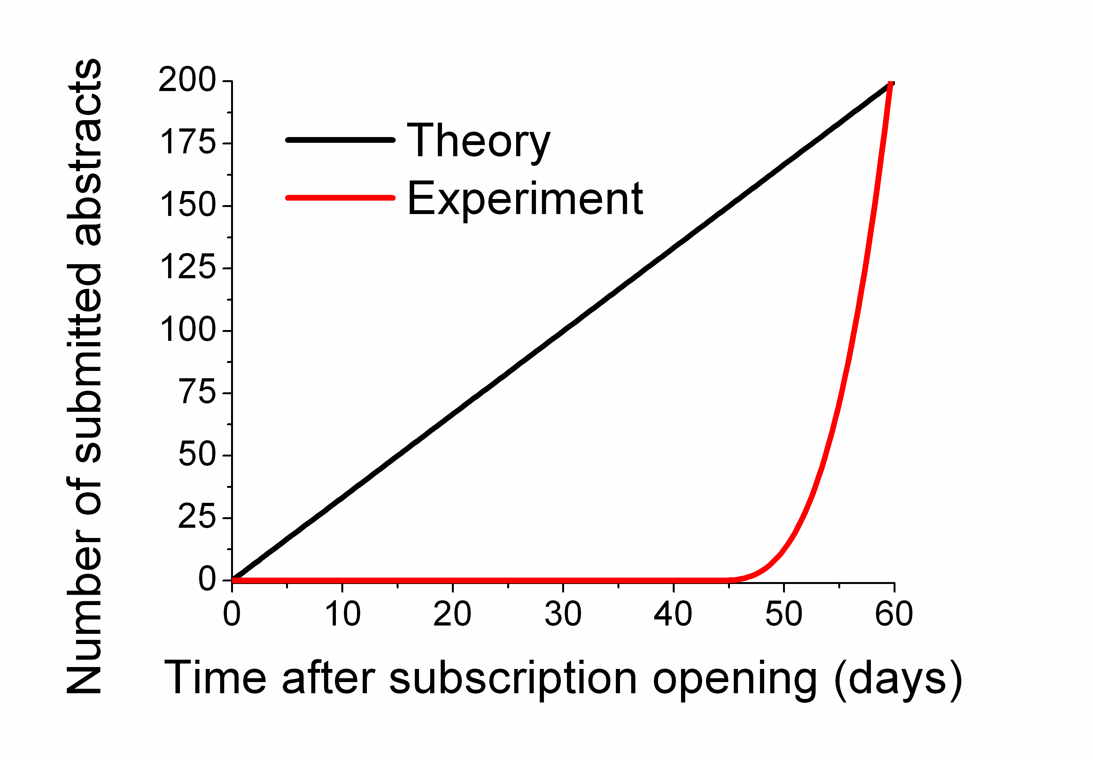

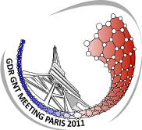
Figure 2 : Number of submitted abstracts versus time : theory in black and experimental values in red.

Figure 1 : GNT 2011 conference logo.

